Task 1

# 

# 

# 

# 

# 

# 

# 

# 

# 

# 

# 

# 

# 

# 

# 1. Domain Conceptual Model

1.1 Use case class diagrams

Buy flowers

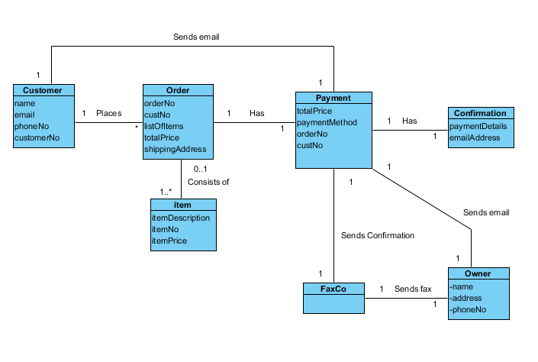

Update/Insert/Delete

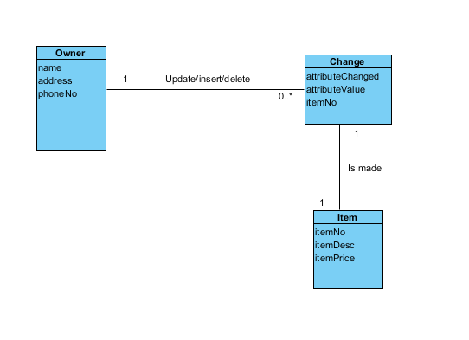

1.2

Domain model

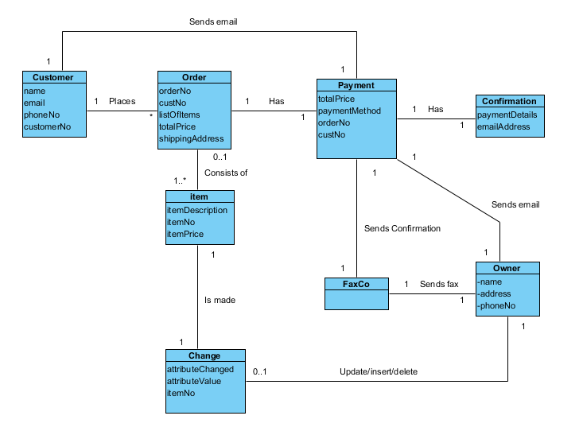

# **2.** **Data dictionary .**

|  |  |  |
| --- | --- | --- |
| Name | Content | Type |
| Customer  Order  Item  Payment  conformation  Owner  ChangeNo  faxco | name + email + phoneNo + CustomerNo  OrderNo + custNo + listofItems + totalPrice + shippingAddress  ItemDescription + itemNo + itemPrice  totalPrice + paymentMethod + orderNo + custNo  paymentDetails + emailAddress  Name + address + phoneNo  attibuedChanged + abbiteuedUpdated + itemNo  none | Class |
| Name  Email  phoneNo  CustomerNo  OrderNo  custNo  listofItems  totalPrice  shippingAddress  ItemDescription  itemNo  itemPrice  paymentMethod  paymentDetails  emailAddress  attributedChanged  abbiteuedUpdated |  | Attribute/Element |
| Ordering Flowers | {Customer + order + payment} | Dataflow |
| Email | {Payment + faxco + ower} | Dataflow |
| Update | {Owner + change + item} | Dataflow |
| insert | {Owner + change + item} | Dataflow |
| Delete | {Owner + change + item} | Dataflow |

Task 2

## Functional Requirements

* System should provide navigation menu divided into categories provided
* System should display window with example items
* At any page user should be able to view his cart
* System should provide remove item from cart option at any time before payment is done
* System should provide going back to shopping option at any time when any item is in the cart
* System should provide alternative shipping address
* System should provide PayPal and credit card (Visa, MasterCard, Discover, AmericanExpress) payment options

## Non-functional Requirements

Works on Firefox, Chrome, Opera and internet Explorer browsers

10. Look and Feel Requirements

* Stand within the standard for cms design.
* That the design should reflect the real world of flowers
* Content should be displayed on plain clear background

11. Usability and Humanity Requirements

* Everything must be accessible from 2 clicks away.
* Finish buying flowers in five steps or less
* The system should be easily used by people with basic computer knowledge .

12. Performance Requirements

* System is to operate 24 hours per day, 365 days per year
* System should be able to hold information details for minimum 200 items
* System should be able to process up to 1000 orders at the same time

14. Maintainability and support Requirements

* System should allow for updating items details without interrupted work
* System is going to work on Windows 7 operating system but must be compatible with previous system’s versions

15. Security Requirements

* Encrypted credit card information
* Encrypted personal information
* System should not send payment details without all required details entered
* Only owner should be able to insert/update/modify information stored about items

**1.** **Create a data dictionary .**

|  |  |  |
| --- | --- | --- |
| Name | Content | Type |
| Customer  Order  Item  Payment  conformation  Owner  ChangeNo  faxco | name + email + phoneNo + CustomerNo  OrderNo + custNo + listofItems + totalPrice + shippingAddress  ItemDescription + itemNo + itemPrice  totalPrice + paymentMethod + orderNo + custNo  paymentDetails + emailAddress  Name + address + phoneNo  attibuedChanged + abbiteuedUpdated + itemNo  none | Class |
| Name  Email  phoneNo  CustomerNo  OrderNo  custNo  listofItems  totalPrice  shippingAddress  ItemDescription  itemNo  itemPrice  paymentMethod  paymentDetails  emailAddress  attributedChanged  abbiteuedUpdated |  | Attribute/Element |
| Ordering Flowers | {Customer + order + payment} | Dataflow |
| Email | {Payment + faxco + ower} | Dataflow |
| Update | {Owner + change + item} | Dataflow |
| insert | {Owner + change + item} | Dataflow |
| Delete | {Owner + change + item} | Dataflow |